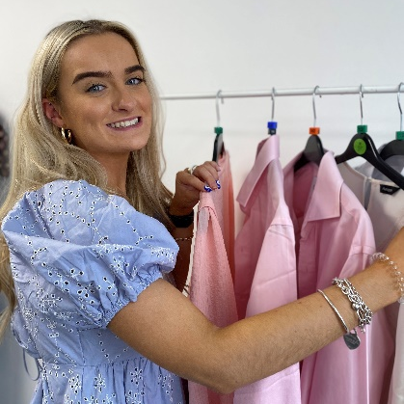
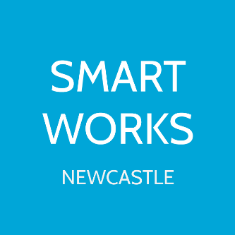
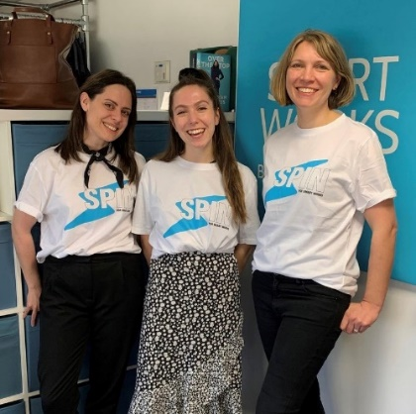
Smart Works Newcastle
Join us as an Admin and Fashion Assistant!

About us
At Smart Works Newcastle we give women the confidence, the self-belief and the practical tools they require to succeed at interview and start a new chapter in their lives. We are incredibly proud that after a visit to Smart Works, more than 70% of the women we support go on to succeed at their job interview.

At the core of the Smart Works service is a two-hour appointment, during which time each woman receives a complete outfit of high-quality clothes (theirs to keep) and dedicated one-to-one interview training. This short intervention has a significant impact as our clients start believing in their own ability to succeed.

Smart Works operates a referral process only: women will be referred from organisations such as Jobcentre Plus, work programme providers, work coaches, housing associations etc. As a volunteer you will work with a wide range of clients to help them onto their journey into employment.

“What I love most about volunteering is knowing that I’ve been a part of someone’s journey into employment. Getting a job is a huge part of life and to have helped contribute to someone’s success is so rewarding. I also love that Smart Works Newcastle is run for women by women, it’s so empowering!”
Cailtin, Current Admin and Fashion Assistant, 2 years
About the role
As the Admin and Fashion Assistant you will support the team with a range of tasks to ensure we can support as many women into employment as possible!
This position is brilliant experience for anyone looking to pursue a career that centres around gender equality, equality of opportunity, social policy and charity work. By playing a vital and varied role within our charity you will gain a wide range of transferable skills including, but not limited to, administration, confidentiality and empathy when working with vulnerable women, events organisation, communications and much more!

Duties and Tasks involve:
- Helping create social media content, including Tik Tik videos, Instgram posts and more
- Use our database to update client records
- Daily admin – answering phone, booking client appointments, monitoring email inbox
- Sort through clothing donations
- Visual merchandising – dressing mannequins, display units
- Organise and tidy stock room
- Oversee eBay sales and listings
- Ad hoc event support (outside of a Monday, including evenings and potentially weekends)
- Styling clients ahead of their interview
- Event planning and support (open mornings, clothing sales etc)

You will need:
- Passion for female empowerment and equality of opportunity
- A strong understanding of confidentiality
- Ability to communicate and empathise with a wide range of individuals
- Team player (as we are a small close-knit team)
- Proactive and ‘get stuck in’ approach
- Understand our service and the impact we have across the North East
- Experience in fashion/wardrobe not needed. Experience in a customer facing role – especially in retail – is desirable.

Commitment
Every Monday for 5 hours between 9am and 5pm. There will be opportunities to volunteer out of the office, at job fairs, networking events, clothing sales and much more. Commitment and enthusiasm towards these are expected on an ad hoc basis.

We ask that you can commit to volunteering for 6 months (we understand that students may not be present during holidays but please still apply).

Application details
To apply please fill out the application form on our ‘Become a Volunteer’ page (linked below) and send it alongside your CV to eilish.malliagh@smartworks.org.uk
Feel free to call 0191 255 1906 or email should you have any questions
https://newcastle.smartworks.org.uk/get-involved/volunteer/
